Laboratory Astrophysics in the Microwave and UV

Kyle N. Crabtree

Department of Chemistry, University of California, Davis, Davis, CA 95616 USA
kncrabtree@ucdavis.edu

Over 200 molecules have been identified in the interstellar medium and in circumstellar shells to date. The abundances and spectral fingerprints of these species convey a wealth of information about their physical environments, providing key insights into the chemical evolution of the universe. With the availability of newer and more powerful astronomical facilities, such as the Atacama Large Millimeter Array, astrophysical objects can now be observed with exquisite spatial and spectral detail. Converting these observations into scientific insight requires the use of complex and dynamic physical and chemical models, in turn requiring rigorous and reliable laboratory data acquired under astrophysically relevant conditions. In this talk, I will focus on recent developments in the application of microwave spectroscopy to laboratory astrophysics, as well as new automated spectral assignment and interpretation strategies. In addition, I will discuss the early results from a new experimental effort to study the VUV photodissociation of the CS molecule.

Biography
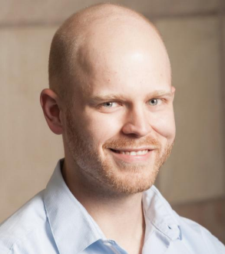
Kyle Crabtree has been an Assistant Professor at the University of California, Davis, since 2014. He earned his B.S. in Chemistry from Ball State University in 2006 and his Ph.D. in Chemistry from the University of Illinois in 2012. From 2012-2014 he was a CfA Postdoctoral Fellow at the Harvard-Smithsonian Center for Astrophysics, where he worked in the laboratory of Dr. Michael C. McCarthy. His current research involves application of microwave spectroscopy for studying chemical kinetics of astrochemically important reactions, developing automated analysis tools for microwave spectroscopy, and measuring VUV photodissociation of transient diatomic species for UV photochemical models of the interstellar medium.

